**SF Lightning project – Austin Soccer**

***Objective:*** Soccer activities in Austin

***Questions:***

* Where is activity ?
* When is activity ?
* How long is the activity ?
* Who all is involved ?
* What is the cost ?
* What other restrictions ? E.g. cost, facility availability, team membership
* TV schedule
* Telecast / Broadcast
* Advertisements
* Frequency of occurrence

Why would anyone want to know about Soccer Activity in Austin ?

* Participation – Youth and Adult
* Exercise options
* Spectators
* Advertisers
* Marketers
* Food Trucks
* TV
* Radio
* Schools
* Sponsorship
* Scholarships

Things to do on Website:

* Search: Facility, Timing, Cost, Location -> Database, Feeds e.g. Meetup
* View Images of Facility
* View map of Facility location
* Sign-up and participate
* Contact organizers
* Review Facility, Activity, etc.

***Goals:***

Show map of Austin.

Show facilities as Markers.

People can click and view Facility info.

***>>> See Wireframe - Austin Soccer PDF document***

Search:

Facility – Location and Images Timing, Cost, Location -> Database

SF Lightning Components:

TRAILHEAD: [armanshah70@brave-raccoon-46791.com](mailto:armanshah70@brave-raccoon-46791.com)

Austin Soccer url: <https://austin-soccer-dev-ed.lightning.force.com/>

Contacts:

Youth / Adult

Coach

Players

Officials

Teams

Team Members

Facility:

Park

Facilities – Soccer Zone

Coaching Centers – Avila

Indoor

Futsal

COTA

Stadiums

Groups:

Association

Leagues

Map – Locations

Daily events

News – Local & International

Places reviews

TV Schedules

Upcoming events

Meetups

Charity Events

Promotions

**Salesforce technologies:**

USE: Lightning, SF Enterprise Patterns Framework, Apex Mocks,

CONSIDER: # of Users, # of Licenses, Data Modeling, Data Volume, Async processes, Triggers, Security, Restrictions, Data Sources, External Feeds, External APIs

Lightning components – handler/register Events, Map, showToast, ui:ScrollerWrapper, callback, Renderer, SVG,

SLDS Grid: <div class="slds-grid slds-wrap"> which uses HTML / CSS

Lightning:layout 🡺 Generates CSS in background

<lightning:layout horizontalAlign="spread" multipleRows="true">

External libraries – ltng:require

Lightning:card

SLDS – SF Lightning Design System

Lightning Experience

Lightning App Builder & Lightning App

Salesforce App - Mobile

Lightning Connect

Lightning Data Services

<p>

<a href="javascript:void(0)" onclick="{!c.onUserInfoClick}"

data-userid="{!boatReview.CreatedBy.Id}">

{! boatReview.CreatedBy.Name}</a> — {! boatReview.CreatedBy.CompanyName}

</p>

PlotMarker:

var lat = event.getParam('lat');

var long = event.getParam('long');

var location = [lat, long];

component.set("v.location", { latitude : lat, longitude : long });

<c:FiveStarRating value="{! boatReview.Rating__c}" readonly="true" />

CONTROLLERS:

Client-side Javascript

Server-side Apex

***--- ISSUE:*** The Facilities do Not match the map.

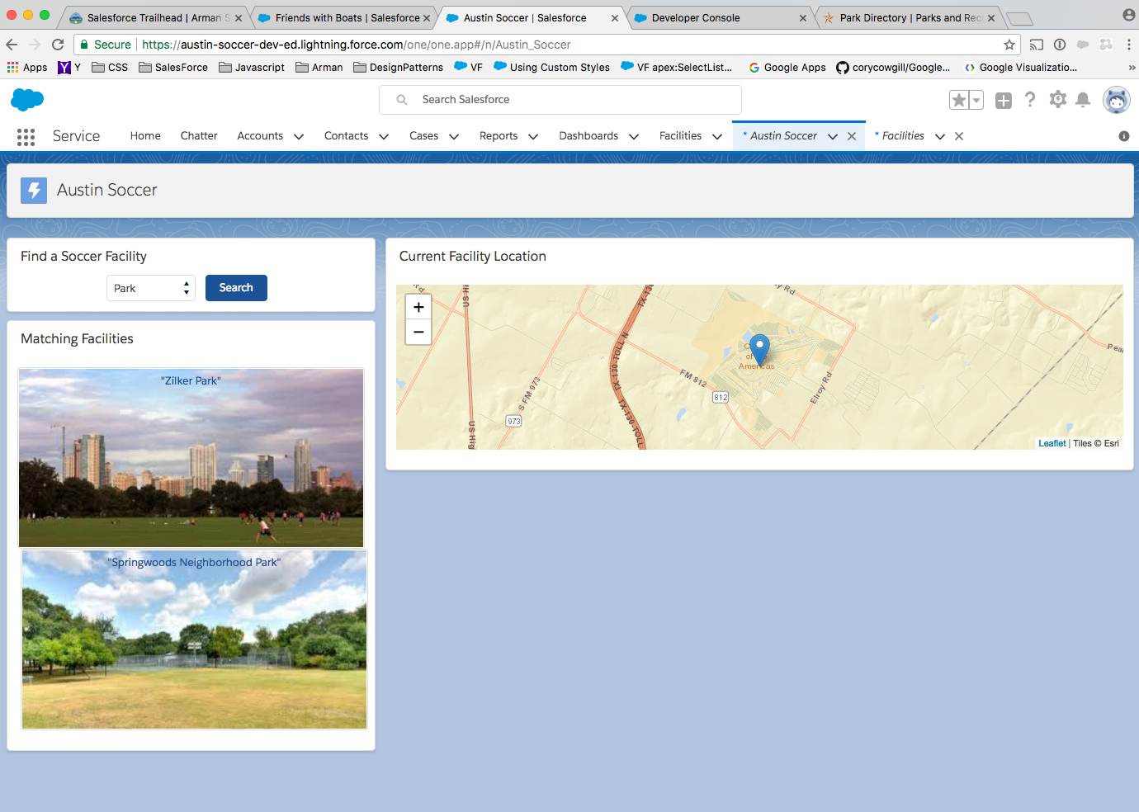

RESOLUTION:

* Added new method named resetMap(); see FacilitySearchResults.cmp and FacilitySearchResultsController.js.
* Added an aura:attribute of “facilityName” to Map.cmp, which is set in the MapController.js -> plotMapMarker function.
* Then since the “longitude” and “latitude” values have been reset to null, thus the MapRenderer.js it will read the “facilityName” value from Map.cmp.

var latLng = [30.277554, -97.740307]; // TX State Capitol default

var facilityName = 'TX State Capitol';

if (location && location.latitude && location.longitude) {

latLng = [location.latitude, location.longitude];

facilityName = component.get('v.facilityName');

}

if (component.marker) {

component.marker.setLatLng(latLng).bindPopup(facilityName);

}

else {

component.marker = window.L.marker(latLng);

component.marker.addTo(component.map).bindPopup(facilityName);

}

component.map.setView(latLng);

***--- ISSUE:*** Fix sizing for Map. Show details for selected Facility.

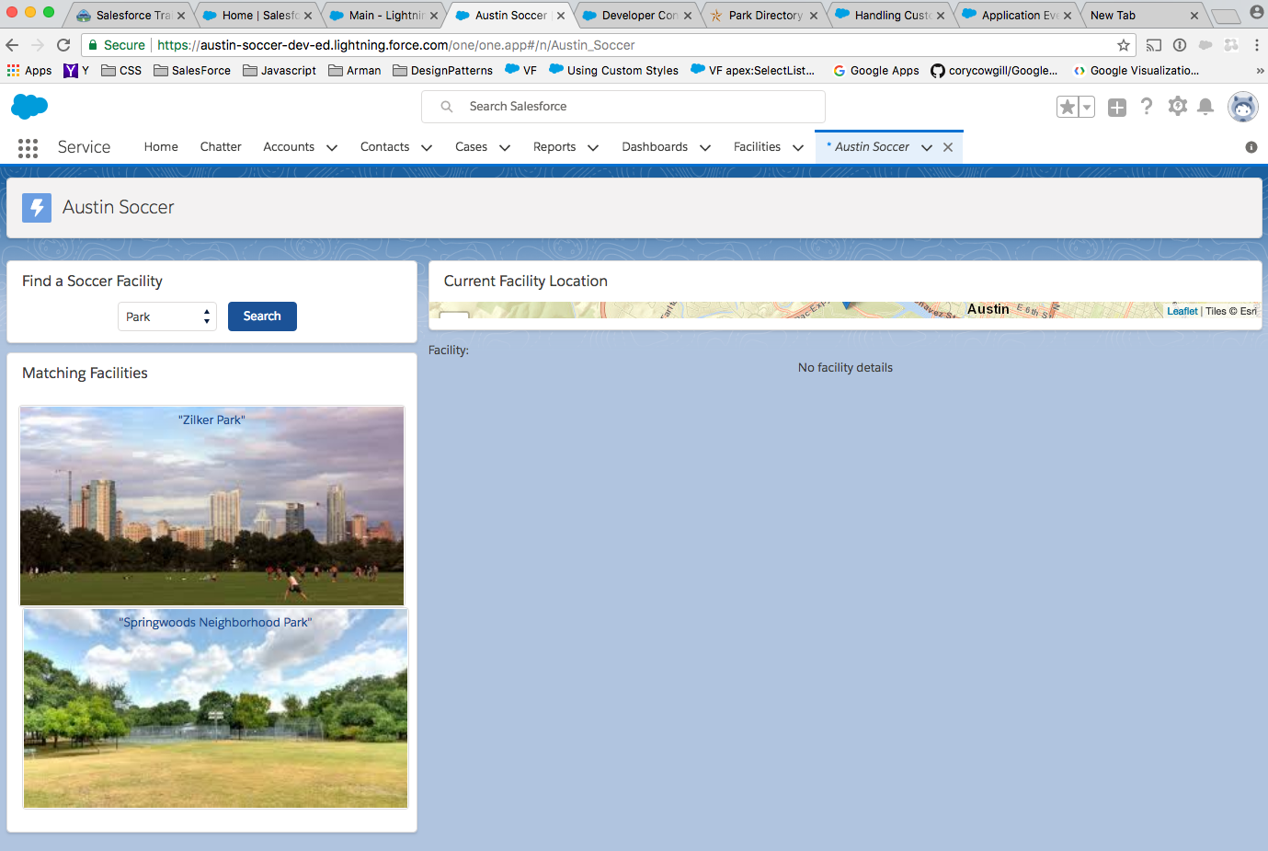

RESOLUTION:

Fix Map.css 🡪

.THIS {

width: 100%;

height: 400px;

}

***--- ISSUE:*** Need to “refresh Map” every time the Facility “Search” button is clicked.

RESOLUTION:

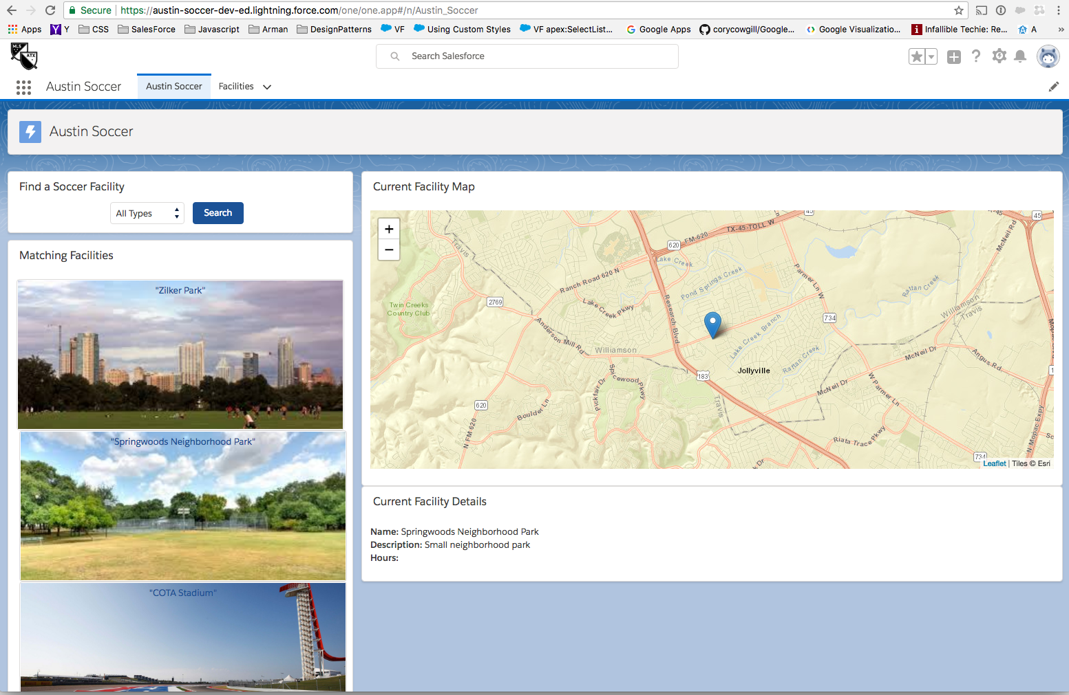

FIX:

Changes made in Map.cmp to handle the “PlotMarker” and “FacilitySelected” events:

<aura:registerEvent name="PlotMapMarker" type="c:PlotMapMarker" />

<aura:method name="resetMap" action="{!c.resetMap}" />

<aura:registerEvent name="FacilitySelected" type="c:FacilitySelected" />

<aura:method name="resetFacilityDetails" action="{!c.resetFacilityDetails}" />

Changes made in MapRenderer.js to “remove layers” when a map reset occurs. Then redraw the Layers later. See MavensMate screenshot below:

